\*\*\*\*\*\*\*\*\*\*\*\*ASSIGNMENT 3\*\*\*\*\*\*\*\*\*\*\*\*

NAME: RAMAVATH SANTHOSH ROLL NO: 22MCF1R40

BRANCH: MCA (CSE) COURSE: CGDA

LEVEL-1:

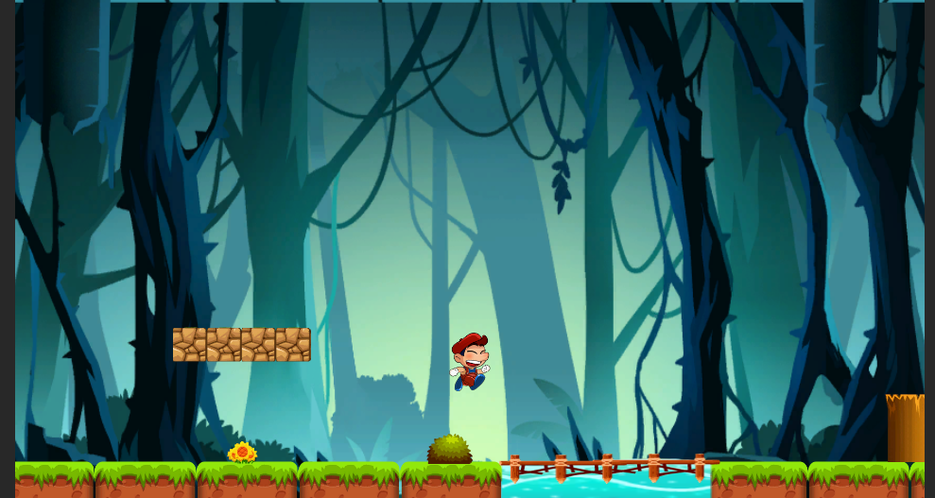

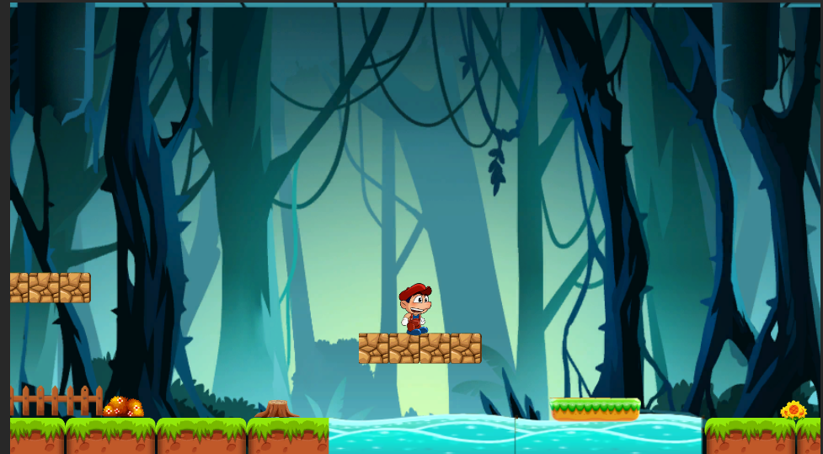

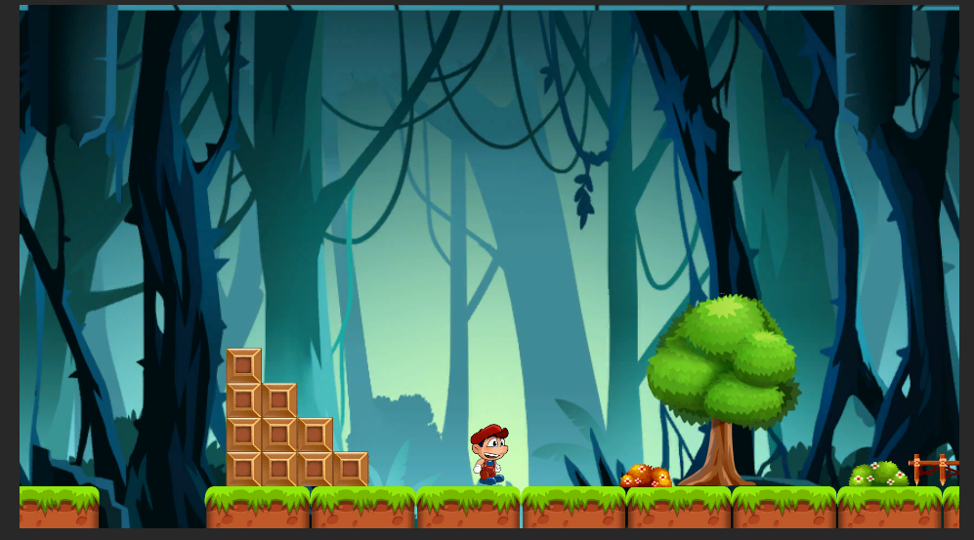

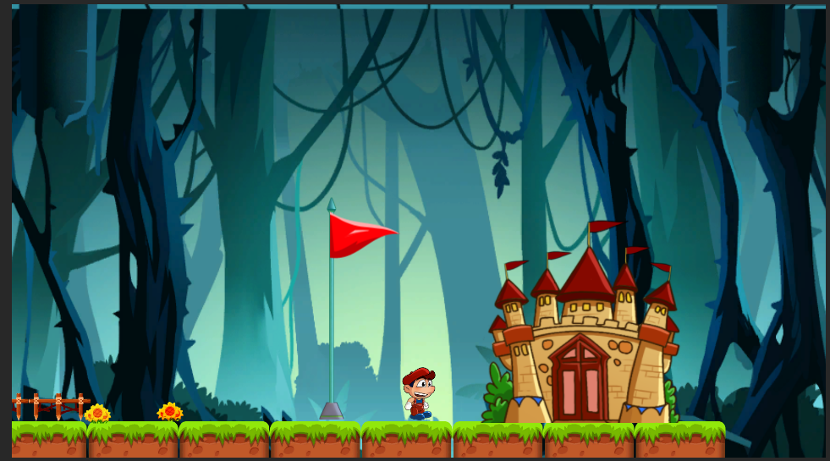

LEVEL-2:

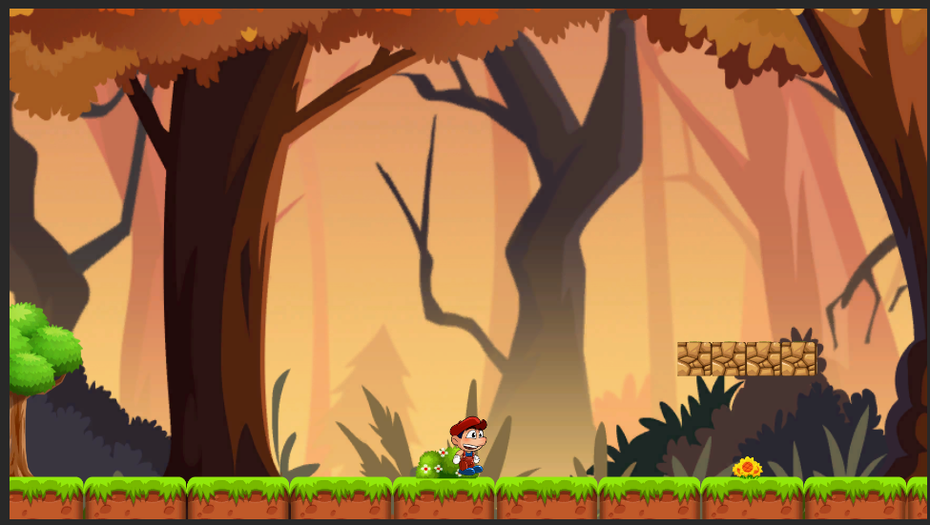

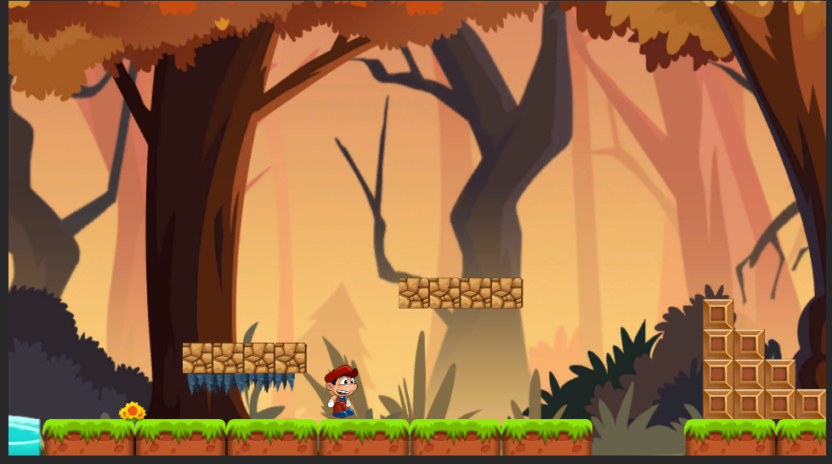

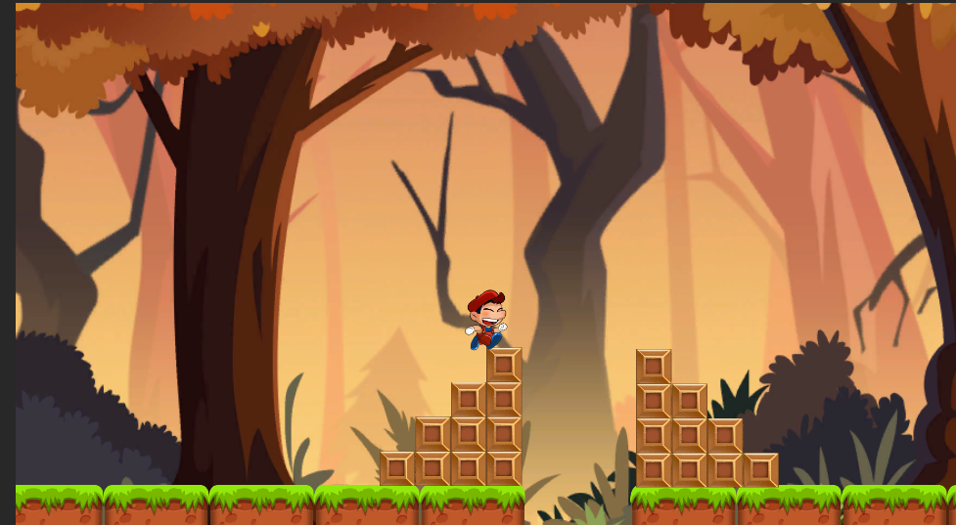

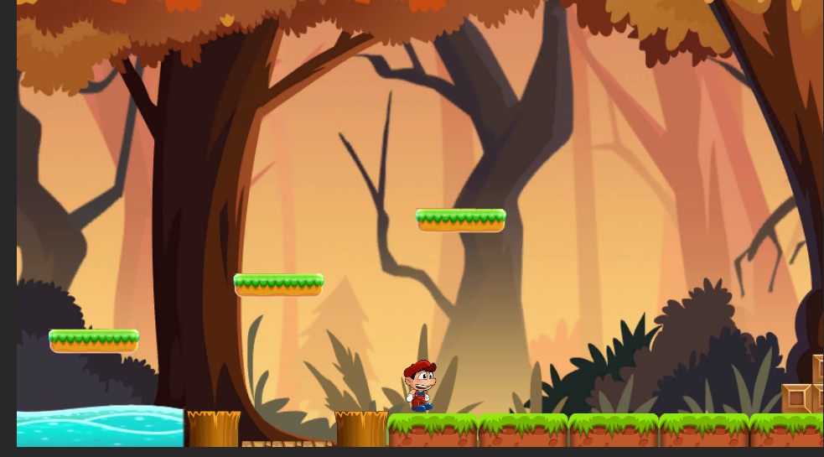

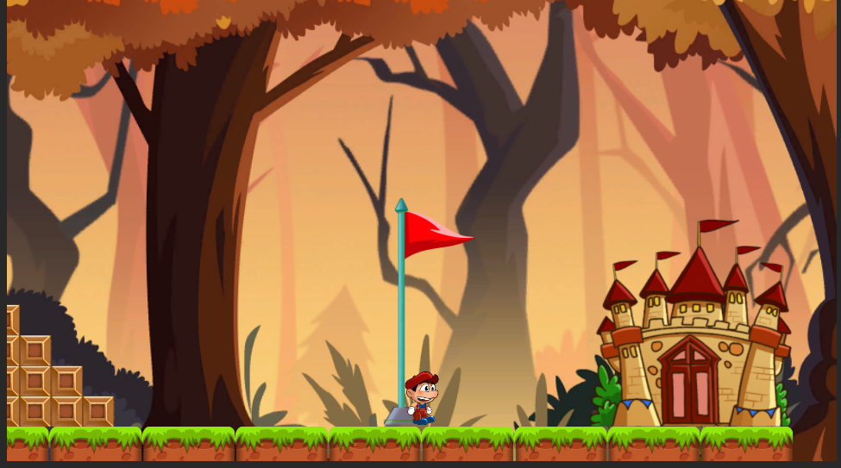

LEVEL2 COMPLETED………………………………………………..,

\*\*\*\*\*\*\*\*\*\*\*\*\*\*\*\*\*\*\*\*END\*\*\*\*\*\*\*\*\*\*\*\*\*\*\*\*\*\*\*